‘Do you know’ questions
Answers
1 Individuals, firms, markets and market failure
1.1 Economic methodology and the economic problem
1 Economic research attempts to use a scientific methodology in observing human behaviour.
2 Capital — machinery; enterprise — Richard Branson (Virgin CEO); land — a shop;
labour — a teacher.
3 Positive statements are those that can be tested against facts to be declared either true or false. Normative statements are subjective opinions that cannot be declared true or false.
4 There are limited, or scarce, economic resources compared to society’s unlimited wants.
5

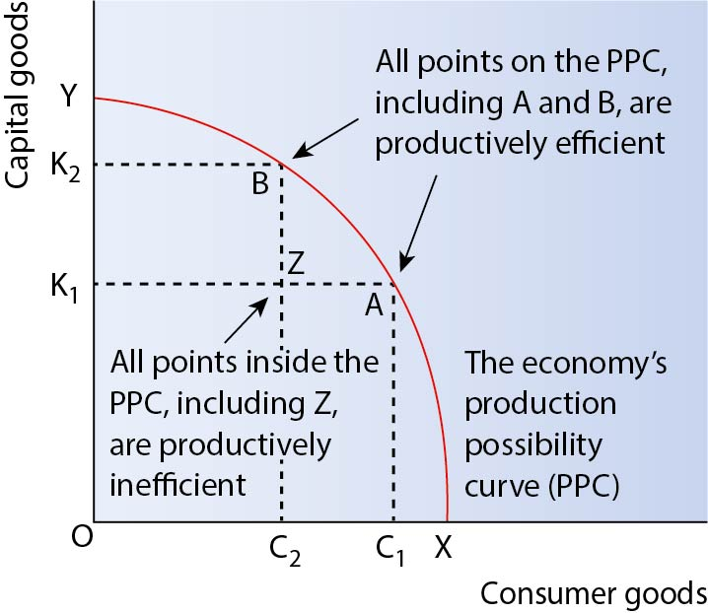
Productive efficiency
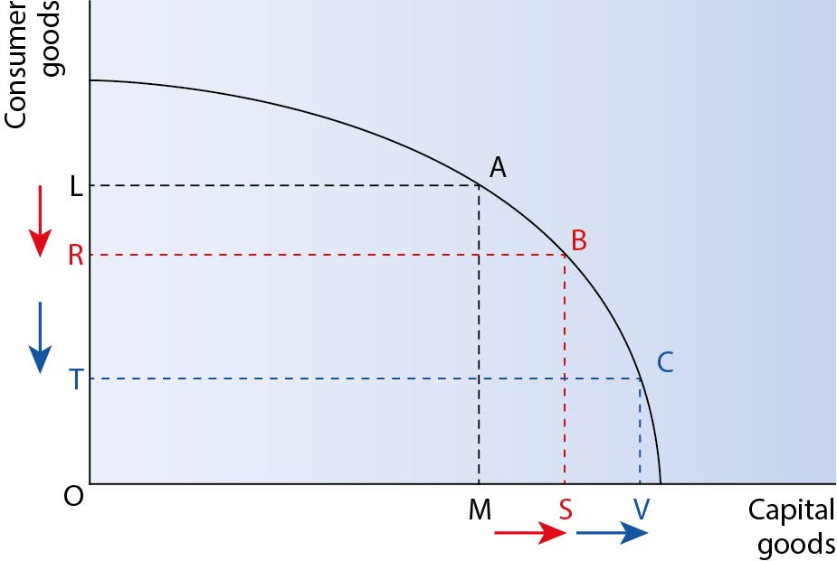
Opportunity cost
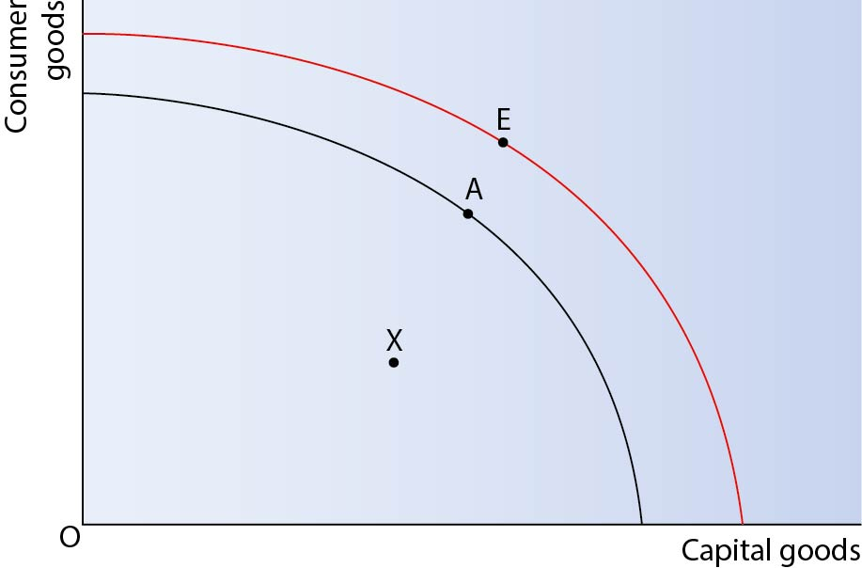
Economic growth
Credit diagrams that correctly show all three scenarios on a single diagram.
1.2 Individual economic decision making
1 As individuals consume more of a good or service, the additional units give successively smaller increases in total satisfaction.
2 Any three of: too little information, too much information, asymmetric information, information presented to exclude certain groups, costs involved in acquiring information.
3 Bounded rationality: when people try to behave rationally but are restricted by factors such as lack of time to make decisions. Anchoring: the tendency of individuals to rely on particular pieces of information when making choices between different goods and services.
4 Nudges use gentle suggestions and positive reinforcement to influence consumer behaviour. Campaigns such as ‘five-a-day’ in relation to fruit and vegetable consumption or ‘10,000 steps per day’ in relation to exercise are examples, as is placing healthy food within easiest reach in cafés or canteens.
1.3 Price determination in a competitive market
1 Any three of: income, tastes and fashions, population, prices of substitutes, prices of complements.
2 Any three of: availability of close substitutes, percentage of income spent on the product, nature of the product, time period, broad or specific market definition.
3 If the product is price elastic, a price cut will increase total revenue while a price rise will reduce total revenue. If the product is price inelastic, a price cut will reduce total revenue while a price rise will increase total revenue.
4 Any three of: production costs, productivity of labour, taxes on businesses, production subsidies, technology.
5 Any three of: time taken to expand supply, size of spare capacity, available stocks, ease of switching production.
1.4 Production, costs and revenue
1 Production: the total output of goods and services. Productivity: output per factor of production per period of time.
2

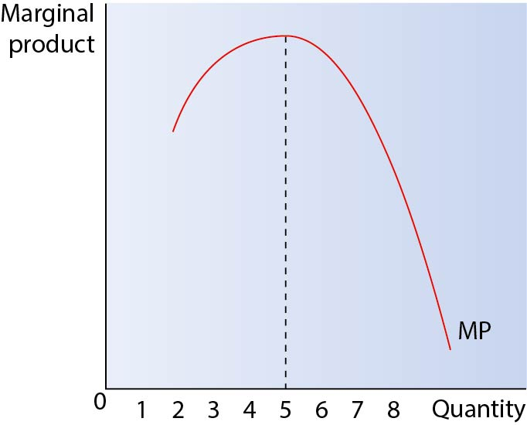
Marginal product increases and eventually decreases as diminishing returns set in
Relevant issues include: definitions of short run, diminishing returns; explanations of diminishing returns.

3

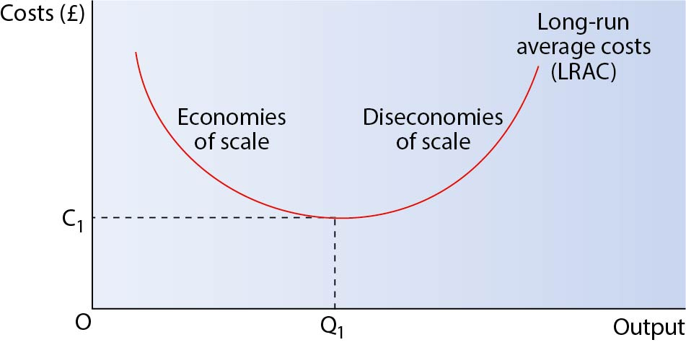
Long-run average cost curve
Relevant issues include: definitions of long run, economies of scale, minimum efficient scale, diseconomies of scale; explanations of each concept.
4 Any three of: technical economies, financial economies, marketing economies, managerial economies.
5

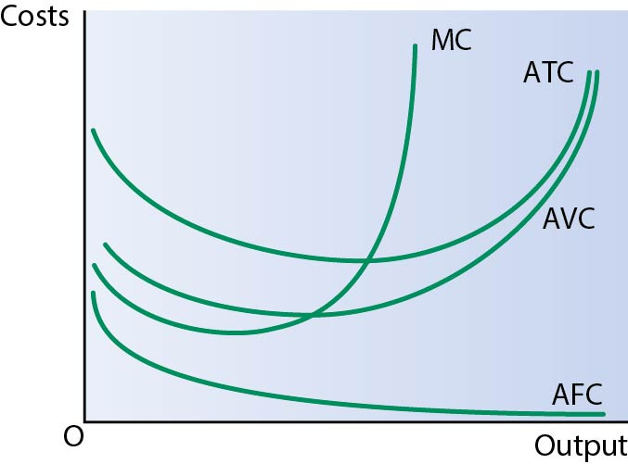
Short-run cost curves
6 Creative destruction is where technological change leads to the development of new ‘disruptive’ products which render existing products obsolete.
1.5 Perfect competition, imperfectly competitive markets and monopoly
1 Perfect competition — any three of: large numbers of buyers and sellers, firms are price takers, perfect knowledge, no barriers to entry or exit, identical products. Monopolistic competition — large number of firms, similar products which are differentiated slightly, low barriers to entry or exit. Oligopoly — small number of powerful firms, highly concentrated markets, interdependence. Monopoly — any three of: single dominant firm, high barriers to entry and exit, imperfect knowledge, supernormal profit in the long run.
2 The owners of limited companies (shareholders) are separate from those who manage the firm (the directors) on a day-to-day basis. Consequently, each may have different objectives.
3 Any three of: profit maximisation, sales maximisation, growth, survival, stakeholder objectives, satisficing.
4

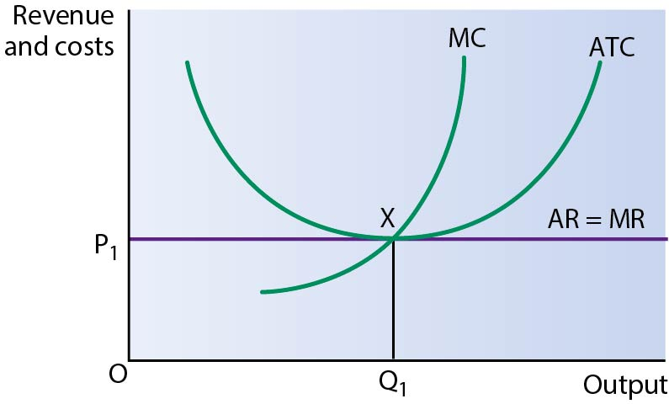
Long-run profit maximisation under perfect competition
Relevant issues include: definitions of long run, perfect competition, productive efficiency, allocative efficiency; explanations of how the features of perfect competition lead to only normal profit at the profit-maximising output in the long run, coinciding with productive and allocative efficiency.
5

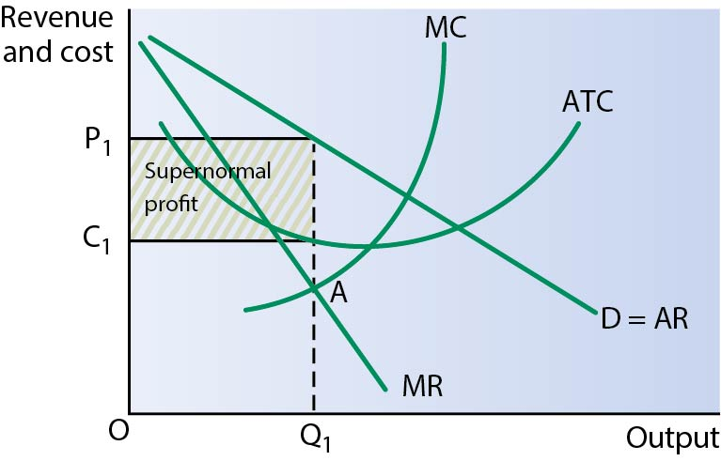
A firm in monopolistic competition in the short run

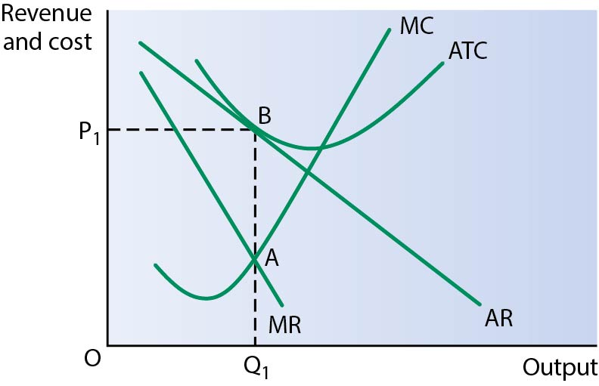
A firm in monopolistic competition in the long run
Relevant issues include: definitions of short run, long run, monopolistic competition; explanations of how the features of monopolistic competition, e.g. some brand loyalty and low barriers to entry, lead to the possibility of supernormal profit in the short run but only normal profit in the long run.
6

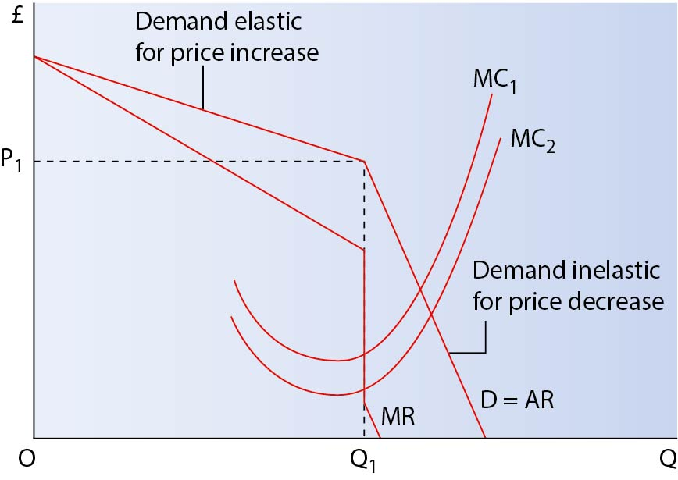
The kinked demand curve model of oligopoly
Relevant issues include: definitions of oligopoly, interdependence; explanations of how firms in oligopoly take the actions and likely reactions of other firms into account in deciding pricing decisions.

7

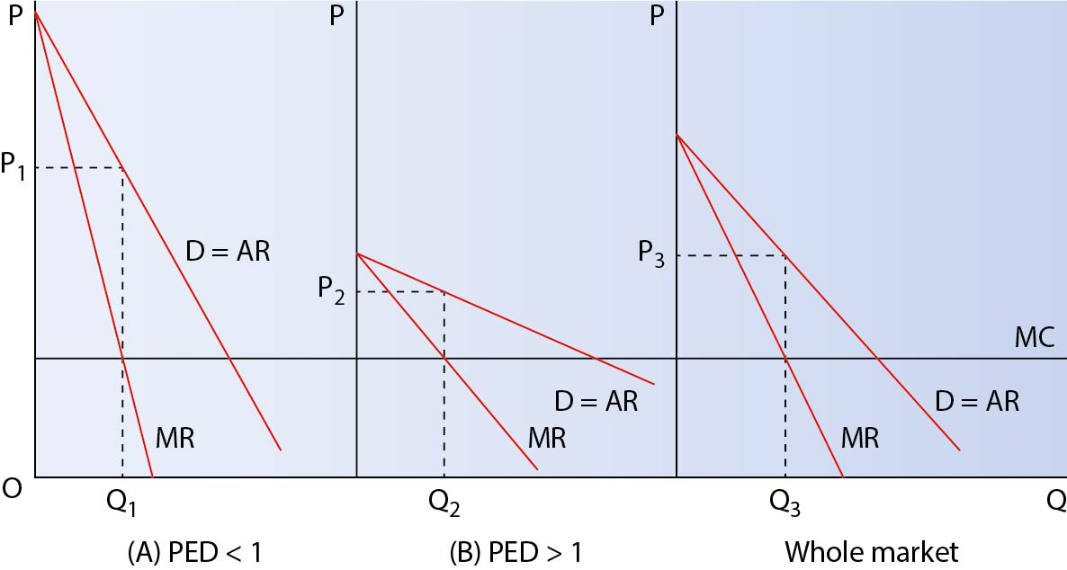
The effects of price discrimination on the profits of a firm with monopoly power
Relevant issues include: definitions of price discrimination, monopoly; explanations of the features of price discrimination and how being able to separate markets into different groups of consumers increases producer surplus at the expense of consumer surplus.
1.6 The labour market
1 Marginal revenue productivity is the increase in revenue gained by a firm from employing an additional unit of labour, calculated by multiplying marginal physical product by the price of the product. Firms will equate MRP with the wage rate to determine how many workers to employ.
2 Any three relevant changes of: wage rates, labour productivity, price of substitute factors, other labour costs.
3 Wage rates, size of working population, non-monetary factors.
4 A perfectly competitive labour market is one in which firms are wage takers, workers are homogeneous, there is freedom of entry and exit, and there is perfect information.
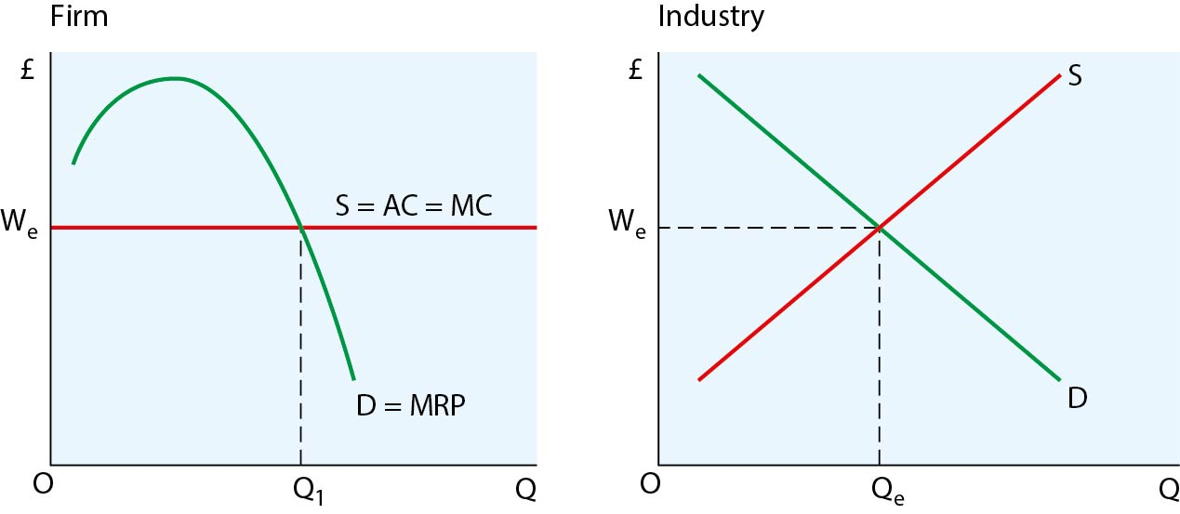
5

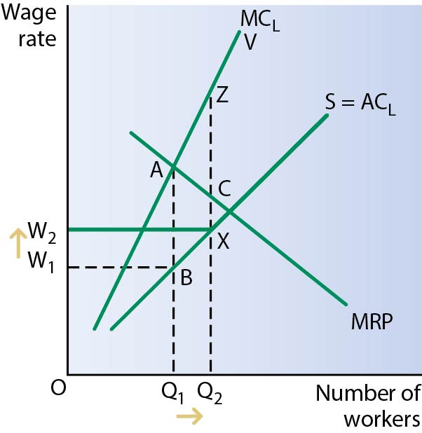
The effects of introducing a trade union to a monopsony labour market
Relevant issues include: definitions of trade union, monopsony; explanations of how this leads to a higher wage and level of employment than without the trade union.
6

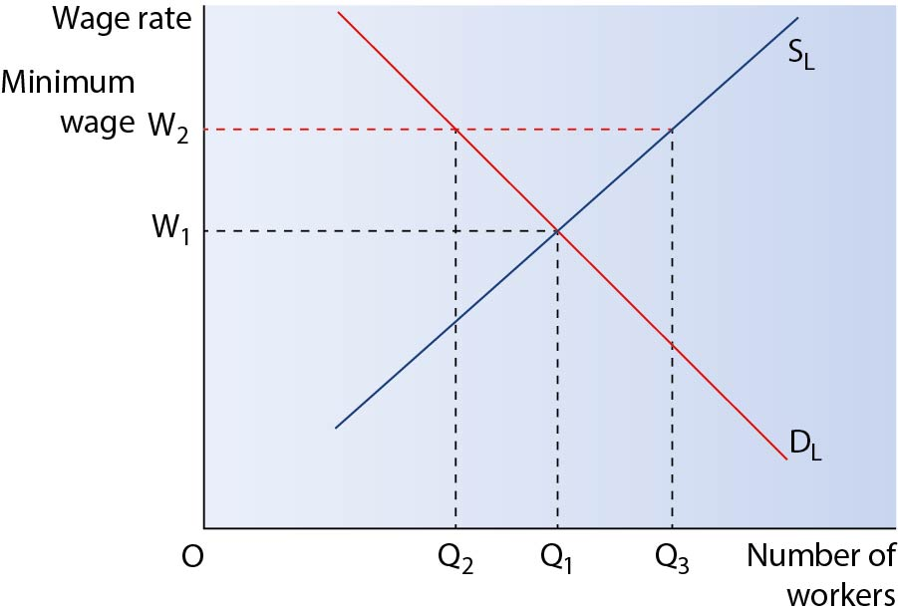
The effects of introducing a national minimum wage
Relevant issues include: definitions of national minimum wage, wage rate; explanations of how this is predicted to increase wage rate for those in receipt of the minimum wage, but may reduce overall employment.
1.7 The distribution of income and wealth: poverty and inequality
1 Income is a flow of money to a factor of production, whereas wealth is a stock of valuable assets.
2 Differences in skills, qualifications and work experience, differences in wealth, impact of the state.
3 Any three of: differences in income, inheritance, marriage, property.
4 Costs: social tensions, the creation of an underclass. Benefits: incentive effects, ‘trickle down’.
5 Relative poverty is when people are poor in relation to others in society. Absolute poverty is when people do not have the basic necessities for survival.
6 Any three of: progressive taxation, national minimum wage, welfare benefits, education and training, reducing unemployment, promoting ‘trickle down’. Credit correct explanations.
1.8 The market mechanism, market failure and government intervention in markets
1 Non-excludability and non-rivalry.
2

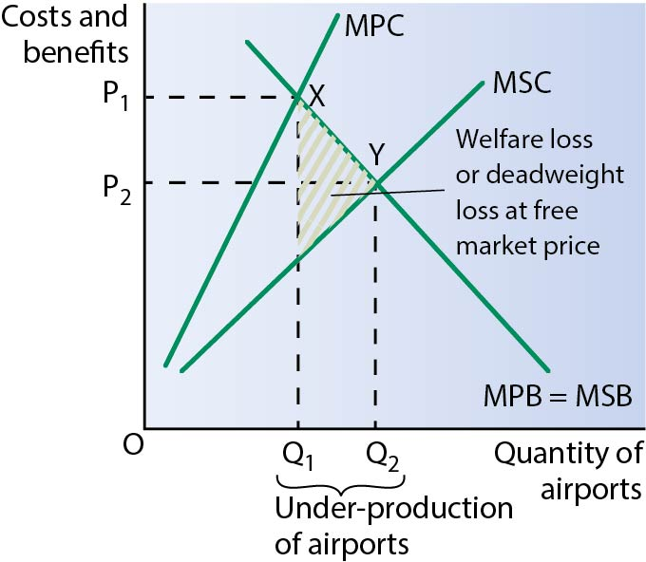
Positive externalities in production

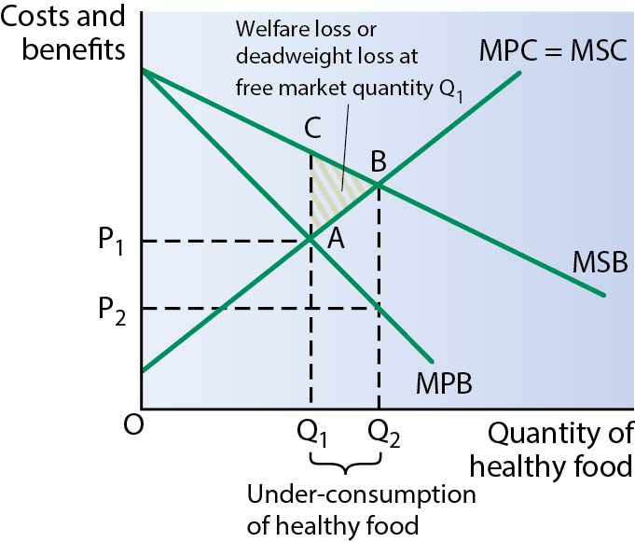
Positive externalities in consumption

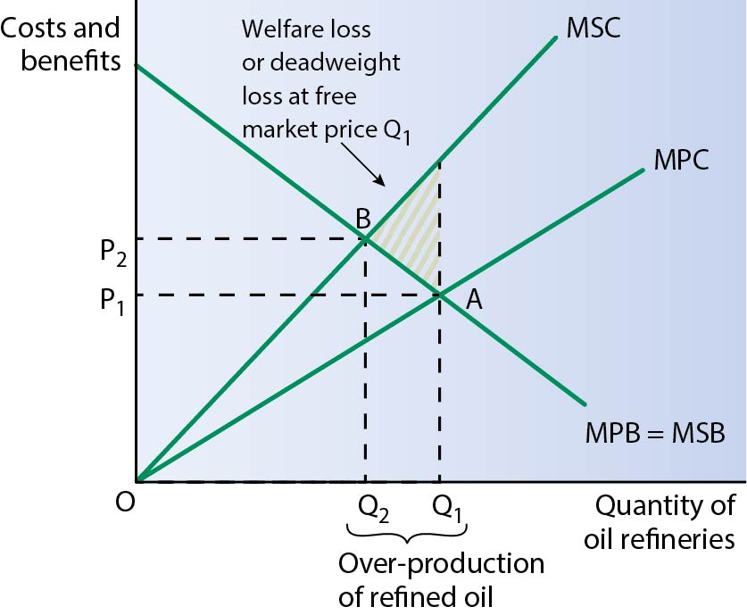
Negative externalities in production

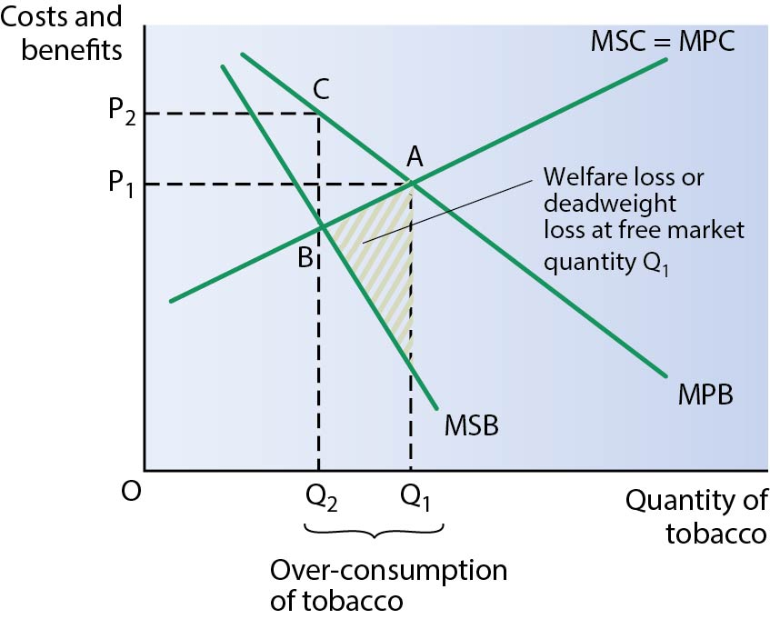
Negative externalities in consumption
3 Lack of understanding of benefits to the individual, both in the short run and long run; lack of understanding of external benefits; too expensive.
4 Advantages: use of the price mechanism, hypothecation of tax revenues.
Disadvantages: difficult to internalise external costs, inelastic demand may not reduce quantity demanded by much.
5 Any three of: compulsory break-up, windfall taxes on excess profits, maximum prices, nationalisation, privatisation, deregulation. Credit relevant explanations.
2 National and international economy
2.1 Measurement of macroeconomic performance
1 Stable economic growth, low inflation, low and falling unemployment, balanced budget, balance on current account of the balance of payments.
2 As economic growth increases, there may be rises in inflation and an increase in the deficit on the current account of the balance of payments. More growth means more spending, which can lead to rising prices and more spending on imports.
3 It is a number used to represent the average level of prices at a point in time. Inflation is calculated as the change in this index number over time.
2.2 How the macroeconomy works
1 The multiplier is 4.
2

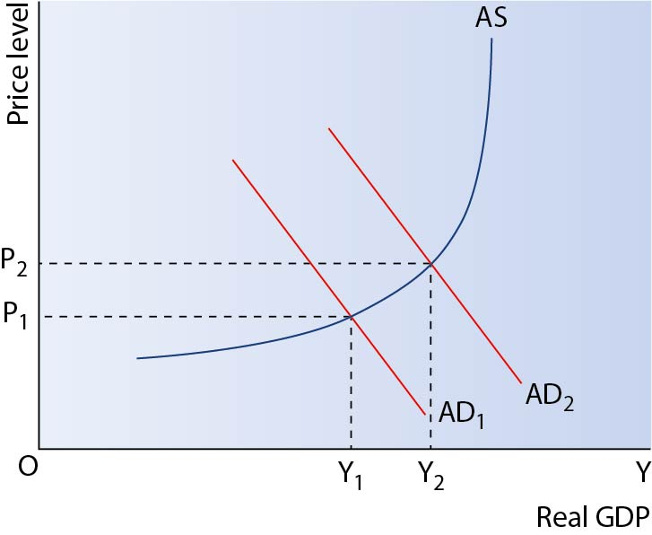
Effects of an increase in consumer confidence
3

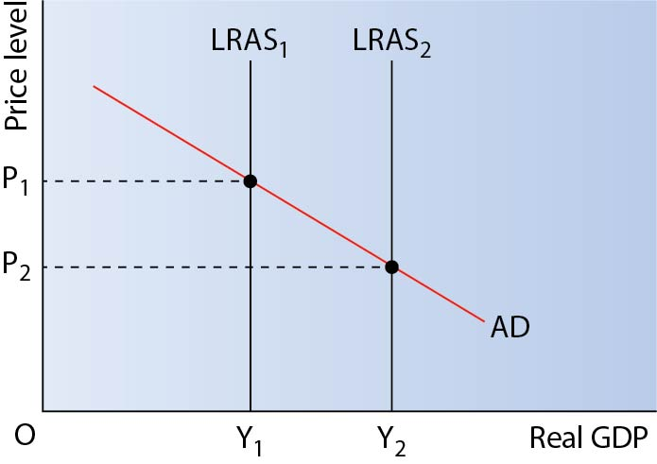
Effects of increasing the retirement age
4 The LRAS is vertical and this means the level of real GDP is constant regardless of the price level. The Keynesian AS curve is initially horizontal, meaning real GDP can expand with no inflationary pressure. Eventually the Keynesian AS curve becomes vertical just like the LRAS.
5 There would have been a fall in AD due to low confidence and downward multiplier effects. There may also have been a leftward shift in the LRAS as banks became less willing to lend.
2.3 Economic performance
1 Positive output gap: above average economic growth, rising inflation, low unemployment, deficit on current account. Negative output gap: below average economic growth, low inflation, rising and/or high unemployment, surplus on current account.
2 Demand–pull inflation — caused by excessive growth in AD. Cost–push inflation — caused by increases in the costs of production; excessive growth in the money supply.
3 Demand-side causes are based on a lack of AD not generating sufficient spending for workers needed to produce output. Supply-side causes are based on failings in the workings of markets — e.g. workers choosing not to work, workers being immobile, welfare provision being too generous, etc.
4 In the long run, workers have rational expectations and will push wages up to compensate for higher inflation. This means that the number of workers employed will fall as firms have to give workers (in the long run) higher wages.
2.4 Financial markets and monetary policy
1 All the money markets channel money from those with a surplus to those with a shortage who are able to pay to access the money. The money market deals with short-term needs for money. The capital market deals with trade in medium-term needs for money (in the form of bonds and equity). The foreign exchange market deals with transactions between different currencies for either immediate need or future needs.
2 Commercial banks generally operate for the benefit of consumers who wish to use banks to store their deposits securely, and also may need to borrow money. Investment banks arrange finance for other banks, governments and businesses — usually through trade and issue of bonds and shares.
3 Higher interest rates will reduce the level of AD. This will lead to lower unemployment and higher growth, but possibly higher inflation. Higher interest rates may also lead to a rise in the exchange rate, which will lead to lower exports but also lower (cost–push) inflation.
4 There are a number of methods of regulation in the UK. The regulatory bodies include: PRA, FPC and FCA. Other forms of regulation include the funding for lending scheme.

2.5 Fiscal policy and supply-side policies
1 Direct taxes create disincentives for individuals to work and engage in economic activity. Shifting the burden to indirect taxes allows these incentives to increase.
2 Government spending takes place for many reasons, such as: reducing poverty and inequality, managing the macroeconomy, improving the productive capacity of the economy, providing public and merit goods.
3 A budget surplus will mean no borrowing is needed, and previously-issued bonds will be paid off as they reach maturity, reducing the national debt.
4 Cuts in income tax will boost AD and may lead to higher inflation. In the long run though, cuts in income tax may improve work incentives and lead to increases in LRAS — thus leading to lower inflation.
5 Government spending on factors affecting LRAS will improve the supply side of the economy. For example, spending on transport infrastructure and education will improve the supply side.
2.6 The international economy
1 Arguments in favour of attracting FDI include: gains from tax revenue, gains in employment, transfer of better technology. Arguments against attracting FDI include: damage to the environment, loss in local businesses, minimal gains in tax revenue and employment.
2 Assumptions made include: perfect knowledge, factor mobility within a country, minimal transport costs, lack of factor mobility between countries.
3 A devaluation will make exports appear cheaper in foreign currency terms, but will also make imports more expensive in domestic currency terms. Exports should increase and imports should decrease eventually, improving the balance on the current account. However, this may take time due to relative price inelasticity for exports and imports in the short term. The balance may get worse as volumes are relatively unaltered in the short term, but the imports purchased are more expensive.

4

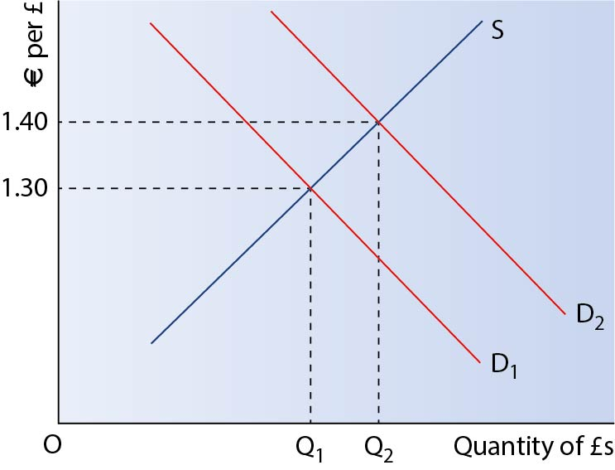
A rise in demand for the pound will lead to a rise in the exchange rate
5 Aid can generate improvements in living standards and welfare for the population. However, this will depend on whether the aid is used wisely, is channelled to the right people who need help and is in an appropriate form. Otherwise, aid may not be especially helpful.

