End of section questions
Notes for answers
1 Individuals, firms, markets and market failure
1 One who consumes a good or service only if the perceived satisfaction is greater than, or equal to, the price.
2 A good whose consumption increases when incomes increase.
3 Focusing on producing a limited range of output.
4 Where firms with monopoly power charge different groups of consumers different prices for the same product.
5 Where government intervention to correct market failure leads to a worse allocation of resources.
6

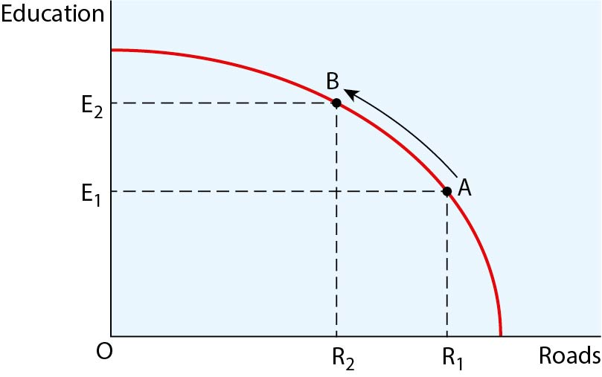
The opportunity cost situation facing governments when deciding whether to spend
on transport or education
Relevant issues include: definitions of PPC, opportunity cost, public spending; explanation of how a trade-off exists when the government decides to spend its money in a certain way.

7

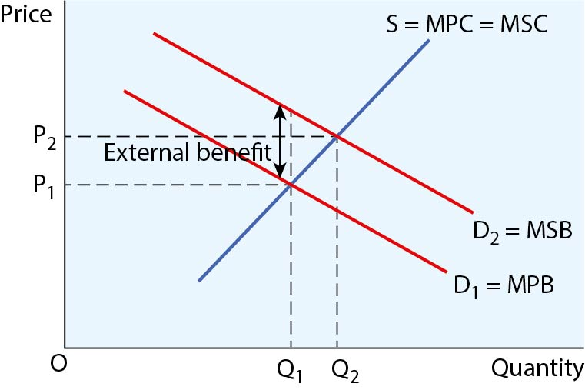
How mandating choices might influence a market towards desirable outcomes
Relevant issues include: definitions of behavioural economics, choice architecture, mandated choice; explanations of the diagram and policy in terms of increased demand of merit goods towards the social optimum.
8
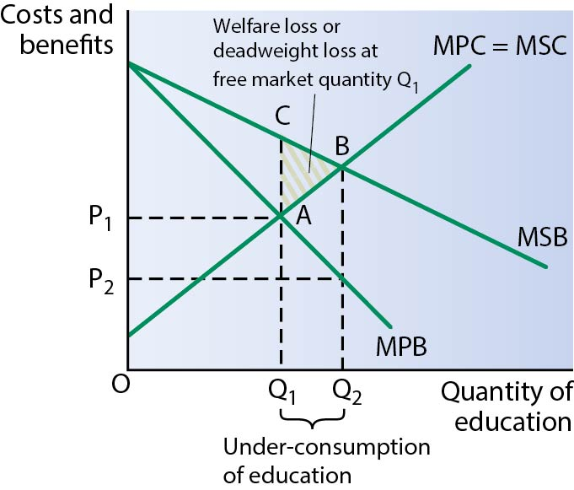
Relevant issues include: definitions of merit good, imperfect information, free market; explanations of how imperfect information in relation to the current and future private and external benefits leads to under-consumption of Q₂ – Q₁ in the diagram.
9 Possible answers include: higher education and training leading to higher productivity; unique skills that make it difficult to substitute for other factors of production; trade union membership; wage discrimination; length of required training.
10 In the short run, a firm’s unit costs of production are likely to fall and then rise due to the law of diminishing returns, as additional units of output, after a point, cost marginally more to produce. In the long run, as the scale of output is varied, it is possible that the percentage change in output could be greater than the percentage change in inputs, signifying increased productive efficiency.
11 Relevant points include:
- Definitions of productive and allocative efficiency.
- Diagram(s) showing points of productive/allocative efficiency.
- Features/assumptions of perfect competition that lead to long-run profit maximisation being at the productively/allocatively efficient output: large number of small firms, price takers, perfect information, freedom of entry/exit, homogeneous product.
12 Benefits include: increased competition, lower prices, increased quality/customer service.
13 Relevant points include:
- Definitions of occupational immobility, geographical immobility, inequitable distribution of income and wealth.
- Linked to structural unemployment, inability to contest for jobs may constitute market failure as some individuals may find themselves in undesirable levels of poverty.
- This can lead to external costs such as increased pressure on health services, social tensions and crime.
- Credit use of relevant diagram(s), e.g. external costs, labour market diagrams.
14 Relevant points include:
- Definition of trade unions, wage rates.
- Diagram(s) to illustrate effects of trade unions on wages and employment in perfectly and imperfectly competitive (i.e. monopsony) markets.
- Alternatives: national minimum wage, education/training, tackling labour discrimination.
- Relative merits of the various methods.
15 Relevant points include:
- Explanation of remit of CMA, theoretical benefits of increased competition.
- Justifications for increased competition in industries such as transport, supermarkets and banking.
- Explanation of policy methods.
- Diagram(s) to illustrate how policies might work.
- Potential for government failure, e.g. regulatory capture.
16 Relevant points include:
- Definition of market failure.
- Explanation of the market failure(s) associated with waste disposal, e.g. negative externalities.
- Relevant diagram(s), e.g. negative externalities, indirect taxation, subsidy, pollution permits.
- Discussion of the effectiveness of various intervention methods.
17 Relevant points may include:
- ‘Traditional’ policies such as indirect taxes, subsidies, maximum/minimum prices.
- Behavioural economic theory/policy such as nudges, choice architecture and an understanding of individual responses.
- Relevant diagrams, such as over/under-consumption of demerit/merit goods.
- Evaluation may focus on how behavioural economic policy can complement traditional theory.

2 National and international economy
Short questions
1 The output produced by an economy when working at its full capacity.
2 Unemployment caused by the time taken for workers to move between jobs and into and out of employment.
3 Increases in the money supply, increases in quantitative easing or cuts in interest rates designed to boost economic growth.
4 Where the government makes no deliberate attempt to influence the value of the country’s currency.
Longer questions
1 Suggested issues for development:
- Tax cuts will increase AD and normally lead to higher economic growth.
- Tax cuts will potentially increase LRAS due to incentive to work longer hours/supply labour.
- Tax cuts may reduce impact of demand–pull inflation and eliminate positive output gap.
2 Suggested issues for development:
- High growth means incomes (on average) will rise.
- Unemployment is likely to fall.
- Higher chance of inflationary pressures emerging.
- Government finances will move into surplus (or smaller deficit).
- Current account balance will move closer to or further into deficit.
- Negative externalities of production (pollution, congestion, etc.) may emerge.
3 Suggested answers could include:
- Definitions of natural rate and supply side of economy.
- Definitions of types of unemployment.
- Diagrams of LRPC (shifting to left) or LRAS (shifting to right).
- Policies to reduce frictional unemployment — less generous benefits, minimum wage, etc.
- Policies to reduce structural unemployment — better infrastructure, better education, better training.
- Policies to reduce voluntary unemployment — welfare cuts, income tax cuts, etc.
4 Suggested answers could include:
- Definitions of exchange rate/floating exchange rate.
- Diagrams of falls in currency value (increase in supply of currency, or fall in demand for currency).
- A cut in (relative) interest rates in the UK.
- An increase in UK imports.
- A fall in UK exports.
- Falling UK (relative) productivity.
- Rising UK (relative) inflation.
- Speculation.
Essay-style questions
1 Arguments for analysis may include:
- GDP will indicate purchasing power of economy.
- GDP per capita is useful for showing the spending power of ‘average’ member of population.
- GDP correlates well with living standards.
- Needs modification for it to be a better indicator.
- It’s more useful when there is less income inequality.
- Depends on the composition of GDP.
Issues for evaluation:
- A significant shadow economy may make GDP less meaningful.
- Non-financial indicators will matter.
- Real GDP is far more useful.
- Other measures may be useful (e.g. HDI).
2 Arguments for analysis may include:
- Trade-off between unemployment and inflation.
- Trade-off between unemployment and stable current account.
- No trade-off between unemployment and growth.
Issues for evaluation:
- Depends on which objectives being considered.
- Trade-off may exist only in short run.
- Conflict more likely to exist if demand-side policies are used.
- Supply-side policies may avoid the policy conflict in the long-run.
3 Arguments for analysis may include:
- Deficits can indicate weaknesses in the export sector.
- Interest rates may need to be higher to generate a surplus on the rest of the balance of payments.
- Persistent deficits may lead to diminished foreign currency reserves.
- With insufficient foreign currency reserves, a government may have to deflate the economy.
- Deficits often lead to falling currency values, which can boost cost–push inflation.
- Current account deficits may be due to high economic growth, which is more desirable.
- A surplus on the financial account (e.g. from FDI) may ‘cover’ the current account deficit.
Issues for evaluation:
- Deficits that are large when measured in £s may be small when measured as a percentage of GDP.
- Depends on how persistent the deficit is.
- It is one objective amongst others.
- Will depend on whether there is a fixed or floating exchange rate.

